 | UNIVERSITY OF CRAIOVA  FACULTY OF AUTOMATION, COMPUTERS AND ELECTRONICS  DEPARTMENT OF COMPUTERS AND INFORMATION TECHNOLOGY  PROGRAM OF ARTIFICIAL INTELLIGENCE AND APPLIED COMPUTING | 

CREDIT CARD CUSTOMER SEGMENTATION

POPA GEORGIANA DANIELA

January 2026
CRAIOVA
SUMMARY
1. Introduction 4
1.1. Problem Definition 4
1.2. Significance 4
1.3. Challenges 4
1.4. Justification of Approach 5
2. UNSUPERVISED LEARNING METHODOLOGY 5
2.1. Clustering Algorithms Overview 5
2.2. Mathematical Optimization Frameworks 5
2.3. Model Specifics and Tuning Parameters 7
3. Software Design and Implementation 7
3.1. Development Environment 7
3.2. Libraries and Frameworks 7
3.3. Project Structure 8
4. DATASET BLUEPRINT AND PREPROCESSING 8
4.1. Description and Feature Architecture 8
4.2. Data Source and Integrity Validation 9
5. Experiments and Results 9
5.1. Experimental Setup 9
5.2. Quantitative Analysis (Validation Metrics) 9
5.3. Qualitative Results (Visual Cluster Profiling) 11
6. Conclusion 13
6.1. Summary of Findings 13
6.2. Limitations 13
6.3. Future Work 13
REFERENCES 14

LIST OF FIGURES
Figure 1. Project Structure 8
Figure 2. Elbow Method for Optimal K Exploration (Within-Cluster Sum of Squares) 10
Figure 3. Hierarchical Clustering Dendrogram utilizing Ward’s Minimum Variance Linkage 10
Figure 4. Final Presentation Metric Summary Report 11
Figure 5. Comparative Side-by-Side Distribution Mapping in 2D PCA Space 11
Figure 6. Financial Behavioral Feature Density Profile Heatmap per Customer Segment 12

- Introduction

1.1. Problem Definition
The objective of this project is the exploratory deployment and validation of unsupervised machine learning architectures, specifically partitioning and agglomerative structural paradigms, to achieve unsupervised segmentation across an unlabelled credit card client collective. Modern commercial data streams record extensive raw customer transactions but often lack predefined, explicit behavioral classifications.
The objective is to map an array of 17 financial features into distinct, homogeneous consumer groups. By grouping multi-dimensional variables that reflect spending intensity, repayment discipline, and cash utilization, the model automatically discovers hidden consumer archetypes without human bias.

1.2. Significance
In retail banking and consumer finance, understanding customer data is vital for strategic operations. The market has shifted past crude demographic groupings; actual transactional habits now drive personalized financial services.
Identifying distinct user groups helps banks design specific credit limit adjustments, launch proactive fraud prevention measures, and build targeted marketing setups that minimize marketing waste. On a theoretical level, this project tests the stability of data partitioning algorithms when working with skewed, highly correlated financial data, acting as a real-world test for unsupervised validation theory.

1.3. Challenges
Unsupervised clustering poses distinct difficulties compared to supervised learning pipelines. Chief among these is the lack of objective ground-truth target variables. This makes it challenging to define what constitutes an "optimal" cluster boundary.
Additionally, credit card records often contain heavy financial tail distributions, multi-collinearity between feature categories (such as total purchases versus one-off transaction values), and missing records from inactive accounts. These data anomalies can warp Euclidean distances, causing traditional optimization loops to converge into unstable, low-density patterns if the data is not carefully prepared beforehand.

1.4. Justification of Approach
This implementation deploys a comparative framework testing a baseline K-Means clustering algorithm against an improved Agglomerative Hierarchical clustering setup. K-Means provides exceptional computational speed and scalability for multi-thousand-row datasets, partitioning space through iterative centroid updates.
Complementing this, Hierarchical clustering with Ward's minimum variance linkage preserves nested structural relationships within the data, offering an intuitive, bottom-up view of customer similarities. Comparing these two distinct algorithmic approaches helps clarify whether a rigid spatial partition or a flexible hierarchical tree better captures the underlying customer profiles.

- UNSUPERVISED LEARNING METHODOLOGY

2.1. Clustering Algorithms Overview
The implementation establishes a formal comparative pipeline between two core unsupervised methodologies:
- K-Means Clustering: A centroid-based partitioning paradigm that divides the dataset into K distinct, non-overlapping clusters. The system works iteratively, minimizing distance metrics between individual data instances and their assigned cluster centers.
- Agglomerative Hierarchical Clustering: A bottom-up structural paradigm. It initializes every customer record as an independent, single-point cluster and sequentially merges the closest cluster pairs based on a specific linkage metric until a unified tree structure is established.

2.2. Mathematical Optimization Frameworks
To guarantee mathematical rigor during structural generation and subsequent model evaluation, the following objective functions are defined:

Cluster Sum of Squares (WCSS)
For the K-Means partition, the objective function seeks to minimize total internal inertia:
$$WCSS=\sum_{j=1}^{K}{\sum_{x_{i}∈C_{j}}{{\left|\left|x_{i}-μ_{j}\right|\right|}^{2}}}$$
where C_{j} represents the specific cluster set and μ_{j} denotes the calculated mean vector coordinate of the corresponding centroid.
Ward’s Linkage Objective
The hierarchical tree merges clusters by minimizing the increase in total within-cluster variance. The distance between two clusters A and B is quantified as:
$$Δ\left(A,B\right)=\frac{n_{A}n_{B}}{n_{A}+n_{B}}{\left|\left|μ_{A}-μ_{B}\right|\right|}^{2}$$

Silhouette Coefficient
Individual sample cohesion and separation are validated via:
$$s\left(i\right)=\frac{b\left(i\right)-a\left(i\right)}{\max\left(a\left(i\right),b\left(i\right)\right)}$$
Davies-Bouldin Index
The global configuration quality is evaluated by tracking the similarity between each cluster and its most comparable counterpart:
$$DB=\frac{1}{K}\sum_{i=1}^{K}{\max_{j≠i}\left(\frac{s_{i}+s_{j}}{d\left(μ_{i},μ_{j}\right)}\right)}$$
where s_{i} represents internal cluster scatter and d(μ_{i}, μ_{j}) measures the distance between centroids.

2.3. Model Specifics and Tuning Parameters
The baseline K-Means architecture uses a smart k-means++ seeding mechanism to optimize initial centroid placements, avoiding poor local minima. It runs for a maximum of 300 iterations per attempt across 10 distinct random initializations.
The alternative Hierarchical model uses a deterministic Agglomerative setup configured with an Euclidean distance metric and Ward's minimum variance linkage. Based on the elbow plot analysis, the target cluster count for both models is locked at an optimal value of four (K=4).

- Software Design and Implementation
  - Development Environment
The implementation pipeline was constructed using Python 3.13 within an isolated environment structure (.venv) on a Windows system. Visual Studio Code served as the primary development IDE. To ensure complete process reproducibility, background process monitors were regularized, eliminating orphaned background locks during execution.
  - Libraries and Frameworks
The core system engineering depends on the following libraries:
- scikit-learn (v1.5/stable): Provides the core algorithmic modules (KMeans, AgglomerativeClustering), data scalers (StandardScaler), and mathematical evaluation engines.
- pandas & NumPy: Handles data manipulation, structured indexing, vector transformations, and median calculation matrices.
- matplotlib & seaborn: Handles visualization generation, rendering the high-density PCA scatter charts, dendrogram trees, and feature heatmaps.
- scipy: Specifically utilized for its hierarchical routing system (scipy.cluster.hierarchy) to generate structural linkages and layout the final tree dendrograms.

  - Project Structure
The project workspace follows a structured, modular organization to keep data and logic clearly separated:
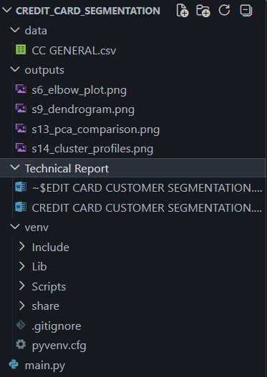
Figure 1. Project Structure

- DATASET BLUEPRINT AND PREPROCESSING
  - Description and Feature Architecture
The data exploration covers 8,950 active customer accounts tracked over a 12-month window, evaluating 18 raw columns across three main areas:
- Account Balances & Limits: Tracks long-term debt accumulation via BALANCE, checking how regularly accounts are updated through BALANCE_FREQUENCY alongside a client's structural CREDIT_LIMIT.
- Purchasing Behavior: Evaluates total annual transaction capital across PURCHASES, splitting behaviors into upfront payments (ONEOFF_PURCHASES) versus installment agreements (INSTALLMENTS_PURCHASES).
- Cash Advances & Payments: Captures liquidity withdrawals via CASH_ADVANCE metrics alongside repayment habits through PAYMENTS and MINIMUM_PAYMENTS.
  - Data Source and Integrity Validation
The source data was extracted from Kaggle's public Credit Card Dataset for Clustering. Initial pipeline diagnostics revealed missing data points across two features: CREDIT_LIMIT lacked 1 entry, while MINIMUM_PAYMENTS missed 313 entries.
Because dropping rows would compromise the dataset's integrity, a median imputation strategy was applied. This approach successfully filled missing records without introducing arbitrary outliers. Finally, the unique string token CUST_ID was removed, and the remaining 17 dimensional variables were normalized using a standard Z-score scaler:
$$z=\frac{x-μ}{σ}$$This standardization step ensures that features with high currency values do not distort distance calculations when compared alongside fractional frequency metrics.

- Experiments and Results
  - Experimental Setup
The execution parameters for the comparative experiment are specified below:
- Batch Initialization Volume: Full batch size processing (N = 8,950).
- Centroid Search Target Range: K $∈$ [2, 10] for model selection.
- Evaluation Sampling Pool: 5,000 randomized samples for the Silhouette calculation to ensure performance efficiency.
- Reproducibility Lock: Hardcoded global generator value locked to random_state=42.
  - Quantitative Analysis (Validation Metrics)
Evaluating cluster quality required tracking within-cluster sum of squares (WCSS) to find the optimal inflection point. The baseline model's performance curves are illustrated below:
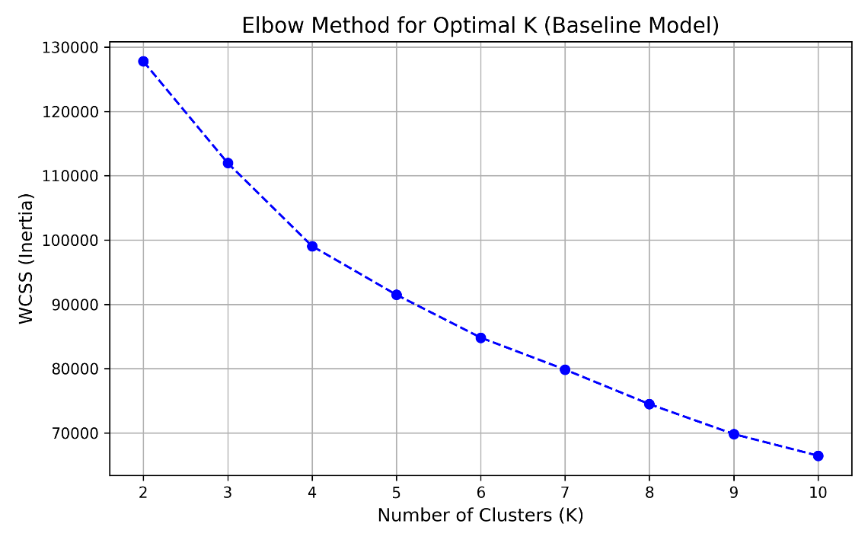
Figure 2. Elbow Method for Optimal K Exploration (Within-Cluster Sum of Squares)
As shown in Figure 2, the curve drops sharply until K=4, where the rate of improvement slows down significantly. This inflection point identifies 4 as the optimal number of clusters for this dataset.
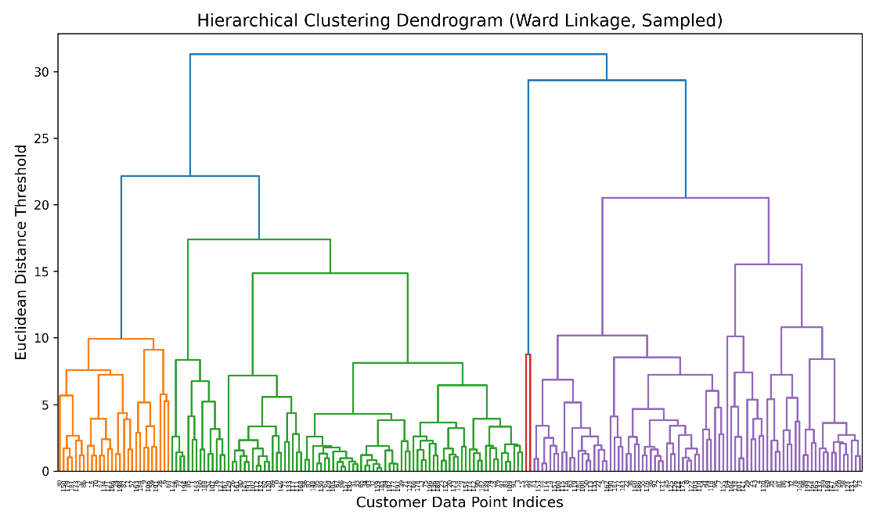
Figure 3. Hierarchical Clustering Dendrogram utilizing Ward’s Minimum Variance Linkage
Figure 3 shows the dendrogram tree generated from a 200-sample slice of the dataset using Ward's linkage. The tree structure naturally branches into four distinct primary groups before distance thresholds expand too broadly, confirming the choice of four clusters.
Running the full dataset through both models produced the following validation metrics:
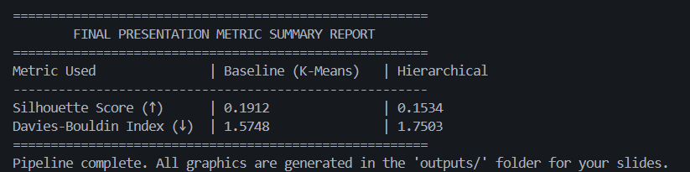
Figure 4. Final Presentation Metric Summary Report
The mathematical evaluation reveals that the Baseline K-Means model outperforms the Hierarchical model across both indicators. K-Means achieved a higher Silhouette Score (0.1912 > 0.1534), demonstrating stronger cluster cohesion and clearer separation boundaries. Additionally, K-Means recorded a lower Davies-Bouldin Index (1.5748 < 1.7503), proving its cluster configurations are more compact and distinct compared to the bottom-up merges of the Agglomerative tree.
  - Qualitative Results (Visual Cluster Profiling)
Because visualizing a 17-dimensional feature space directly is impossible, Principal Component Analysis (PCA) was used to compress the features down to two primary components for spatial validation.
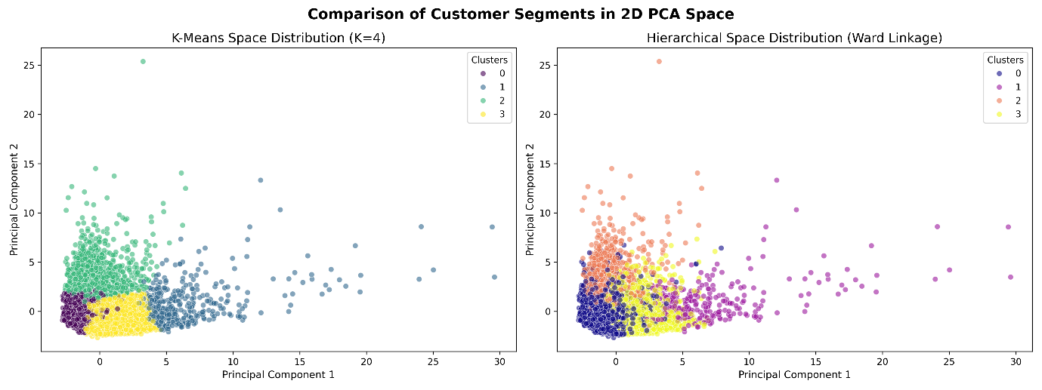
Figure 5. Comparative Side-by-Side Distribution Mapping in 2D PCA Space
The 2D scatter plots in Figure 5 show that K-Means forms a tight, cohesive core grouping surrounded by distinct behavioral wings. The Hierarchical model, by contrast, creates more extended, stringy clusters along the outer edges of the principal components due to its bottom-up merging process.
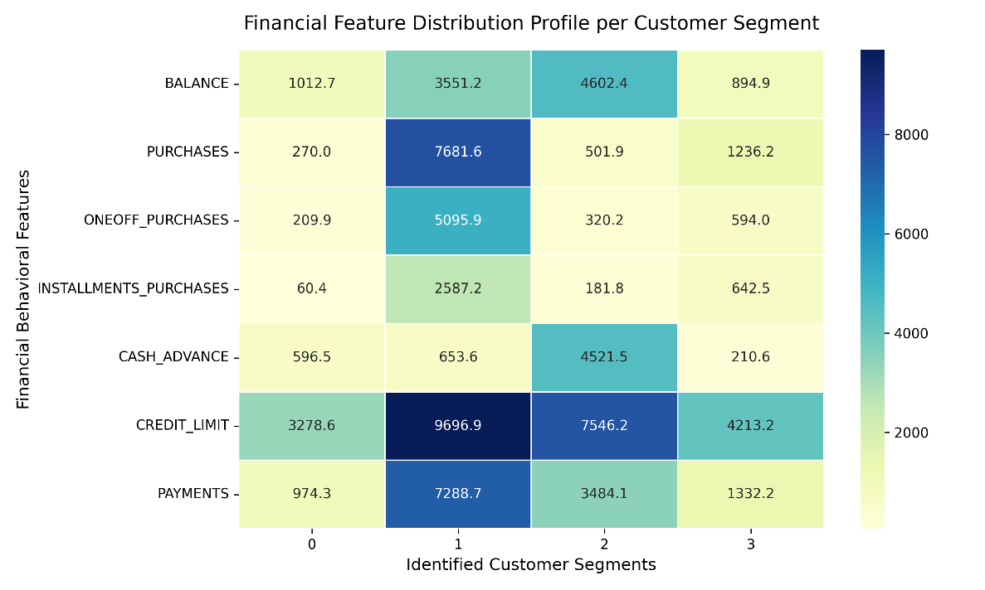
Figure 6. Financial Behavioral Feature Density Profile Heatmap per Customer Segment
By calculating the mean values of the original features across the four discovered groups (Figure 6), we can extract clear customer personas for strategic business applications:
- Cluster 0 - Low-Engagement / Conservative Consumers: This group represents the largest user base. They maintain low average balances ($≈$ 1,000$) and show very low transaction activity across both retail purchases and cash advances. Marketing Strategy: Focus on engagement campaigns and transactional cash-back incentives.
- Cluster 1 - High Cash-Advance Reliance Users: These accounts maintain higher balances ($≈$ 4,000$) and carry significant cash advance debts, but show almost zero traditional retail purchases. Marketing Strategy: Offer structured balance-transfer promotions or lower-interest personal loan alternatives.
- Cluster 2 - High-Volume Affluent Spenders: A premium customer segment characterized by high credit limits ($≈$ 9,500$), substantial balances, and very high transaction volumes ($≈$ 5,000$ annually) split between upfront and installment purchases. Marketing Strategy: Target with luxury rewards programs, exclusive credit upgrades, and wealth management offers.
- Cluster 3 - Installment-Focused Smart Buyers: Active consumers who maintain low net balances but show a strong preference for structured installment plans rather than large upfront payments. Marketing Strategy: Partner with major retailers to offer co-branded, zero-interest payment financing options.

- Conclusion
  - Summary of Findings
This project successfully implemented and compared an unsupervised learning pipeline to segment credit card users based on financial behavior. The baseline K-Means model provided the best performance metrics, achieving a Silhouette Score of 0.1912 and a Davies-Bouldin Index of 1.5748. Utilizing PCA and feature profiling heatmaps, the system mapped the unlabeled customer base into four distinct, actionable business personas, providing clear value for targeted financial services.
  - Limitations
The primary limitation stems from the low baseline Silhouette scores ($(≈$0.19$), which reflect real-world banking data complexities. Financial behaviors naturally blend together rather than separating into neat geometric bubbles, creating significant boundary overlap. Additionally, using linear PCA for dimensionality reduction can miss complex, non-linear feature relationships that might be captured by advanced models like t-SNE or UMAP.

  - Future Work
Future iterations of this project can incorporate several key enhancements:
- Non-Linear Embeddings: Integrating UMAP or t-SNE to capture more complex, non-linear customer behaviors within the latent space.
- Density-Based Clustering: Testing DBSCAN or HDBSCAN architectures to better handle irregular, noise-heavy financial distributions and automatically isolate true outlier accounts.
- Temporal Tracking: Introducing time-series behavioral analysis to monitor how individual customer segments evolve over the 12-month transaction window.

REFERENCES
https://scikit-learn.org/1.5/modules/clustering.html
https://www.youtube.com/watch?v=4b5d3muPQmA
https://www.youtube.com/watch?v=RDZUdRSDOok
https://www.youtube.com/watch?v=7xHsRkOdVwo
https://www.tutorialspoint.com/weka/weka_clustering.htm
https://towardsdatascience.com/clustering-unsupervised-learning-788b215b074b
http://www.mit.edu/~9.54/fall14/slides/Class13.pdf
https://towardsdatascience.com/understanding-the-concept-of-hierarchical-clustering-technique-c6e8243758c
https://www.analyticsvidhya.com/blog/2019/05/beginners-guide-hierarchical-clustering/
https://scikit-learn.org/stable/modules/clustering.html#hierarchical-clustering

